Project Ridiculous

Technical Design Document Compilation

BlueStar

April 19, 2007
[Purpose]

Overview
This document is a collection of the important inner-workings of Zoo Escape. It is intended to summarize the idea and design information of Project Ridiculous into one document to allow quick and easy understanding. This will expedite the process of pitching the project to tech-savvy project leaders and explain the technical side of designing the game to transferring team members.

Product
Zoo Escape is a revolutionary video game that, instead of entertaining the player, attempts to read their thought process by their style of play to deduce the type of task they would excel at. It is designed to be a useful tool to any employer or project leader in determining where to place a group member or employee.

[System Overview]

Platforms Supported

- Windows 2000 or higher (XP, NT, Home Edition)
- Java enabled

Minimum System Specifications

- Windows® 2000 or higher
- Intel Pentium® III or AMD Athlon®
- 256 MB RAM
- 250 MB HDD
- 32MB VRAM
- 16-bit Sound Card
- LAN connection
- Keyboard and mouse
- CD ROM Drive

[Game Overview]

Story
Boulder Zoo has recently sold its land and animals to Zoo’d Food, an underground business that sells exotic animals for food. The night before the deal, a flamingo named Poncho overhears the guards patrolling the zoo talk about what’s going to happen. He decides that he must help the other animals escape their cages so that they can all leave the zoo together and flee from the horrible fate awaiting them.

The player, controlling Poncho, must elude guards and solve puzzles to release the other animals one by one until the population of the zoo can escape death. Each animal has abilities that the player will be able to make use of once they are released. The player must use these abilities wisely to release the other animals.

Gameplay
In Zoo Escape, the player must move about the zoo and find the animals that they can release with the tools already at their disposal. When they get to a particular animal, they speak to it and go through a short dialogue. Depending on their choices, they will either impress the animal, convincing it to leave immediately, or offend the animal, which will refuse to leave with them until they can find an item to appease it. In either case, once the animal is prepared to leave, the player must discern what they have to do to release the animal from its cage. It will require the assistance of those the user has released so far and careful thinking on the part of the gamer.

While they move about the zoo, they must constantly work to avoid the guards patrolling it. Each guard carries a flashlight that—when the beam lightens up an animal—will alert the guard to the presence of the escapees. There is a tool to aid in the elusion, however, in that the player can collect party poppers—small white pouches that make a loud noise when thrown on the ground—and use them to turn the attention of the guards elsewhere.

Analysis
The way that Zoo Escape is played is analyzed by the game itself. Specifically the way the player solves the puzzles of releasing the animals is studied. The game takes the data it compiles from the player’s actions and determines what type of worker they are by rating them in different categories known as Habits of Mind. The Habits of Mind cover such areas as Investigation, Collaboration, and Imagination.

[External Code]

In the execution of Project Ridiculous, some outside programming code was required to ensure that the game would work successfully on schedule. Specifically, OpenGL and OpenAL were used to open and draw the Max files. OpenGL and OpenAL are both freeware programs that were downloaded form the internet.
[Code Objects]
B | BitmapLoader  BlockDataInputStream | loads and applies bitmaps  handles the streaming audio and video files
C | Camera  CameraBlock  Collision  ColorData  ColorRGBA | controls the camera view around the player  The camera’s location, angle, focus point are recorded then the camera is generated  Detects collision with objects and controls  Creates the variables for the three primary colors(red, blue, green)  holds the color values for each and every color in the game
D | Display  DisplaySettings | loads the world and images  controls the resolution of the game depending on different variables (screen size, Alpha, Gamma, etc.)
E | Entity | Every object in the game inherits this class, due to the fact that it sets the base functions for an object, as well as reaction to other objects
G | GameAction  GameEvent  GameEventList  GameState  GameStateManager  GLGraphics  GUI  GUITextList | Determines whether or not a key is pressed and the action to take if it is pressed  Determines if an event is happening and displays the appropriate animation for so long as the event is occurring (works with GameAction to move the player for instance)  Lists the appropriate actions and animations that should occur when an event is triggered (woks with GameEvent to display the animation)  determines the state of the game at that current point in time, then passes control between MenuState and InGameState classes  assists with passing control between MenuState, and InGameState classes.  loads and displays the graphics  handles the player’s interaction with the game itself  generates text to tell the player what happens during certain events(for instance, “You have added Elephant to your Party.”)
I | InGameState  InputHandler | When in control, displays the game and manages player interaction with the “world”  Handles input through threads
K | Kernel | Collection of all the game logic, also keeps track of time(profiler class) and performance records
M | Matrix4f  MenuState | Handles the math functions for anything that uses matrices  When in control, displays the menu and manages the player interaction with the menu
P | PlayerState  PlayerStateManager  Point2d  Point2f  Profiler | Keeps track of all in-game objectives  Acts as a save and load function as well as allowing for the creation of profiles  Determines the location of an object on the 2dplane in “double” variables  Records the location of an object on the 2d plane in “float” variables  Keeps track of time
Q | Quat4f | Creates four float variables for use in determining an object’s location
R | Renderer  ResourceRetriever | renders the image onto the screen/object  loads resources either from the hard drive, or, failing that, from the disk
S | SkyDome | the weather display for the sky around the player
T | Texture  TextureLoader  TextureReader  TrackData | applies the textures to the objects  loads the textures into the game itself  reads the RGBA values for the textures  Tracks the performance records of the game, coloring, light views, positions of objects, material blocks, and Object data. In other words, this is the bug reporter
U | UIComponent  UserInput | Contains the location and behaviors of the buttons  Handles the key assignments for the controls
V | Vector3f  Vector4f | contains math functions for use with and in vector equations with three-point objects  contains math functions for use with and in vector equations with four-point objects
Engine Map Diagram

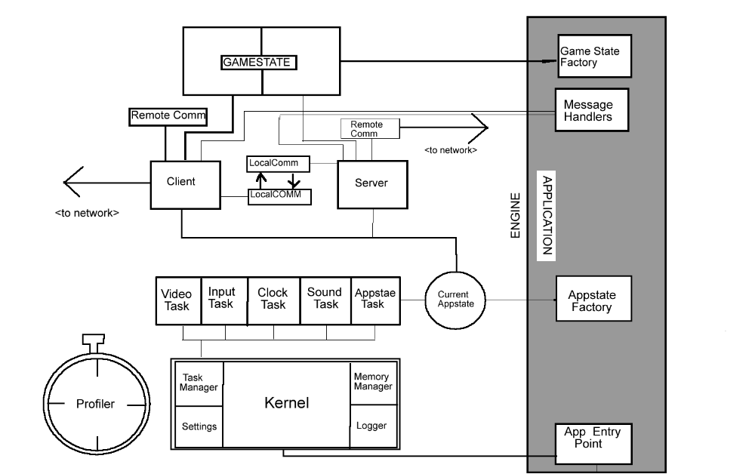
[Control Loop]

  - Begins with the Display Class
  - Imports necessary files for startup.
  - Creates the screen using variables specific to the class.
  - Adjusts screen based on monitor size and resolution.
  - Transfers control to the Renderer class.
  - Imports necessary files.
  - Calls variables for loading images onto the screen and onto specific objects.
  - Sets background images, and prints out first screen.
  - Adjusts variables for screen resolution.
  - Calls the GameStateManager Class.
  - Imports necessary files.
  - Calls the GameState class.
  - GameState creates several variables used in the MenuState and InGameState classes.
  - Runs through MenuState or InGameState, depending on where the user is at the moment. First, it runs through the MenuState before it starts the game itself.
  - Imports necessary files.
  - Creates a variable for handling user input when they click a button.
  - Using this variable, it interprets clicking a certain button as a transfer (for instance, clicking start will make the game start).
  - Continues looping through MenuState (Step16) until user clicks “Start”.
  - When the player clicks start, control is transferred to InGameState.
  - Imports relevant files.
  - Generates the camera view.
  - Loads the player’s avatar.
  - Loads the game map.
  - Loads the sky images.
  - Generates a new action for the mouse wheel, which controls the camera.
  - Switches the controls between moving mode and dialogue mode.
  - If in movement mode: Generates the camera, player, map, and weather.
  - Generates all NPC’s
  - Generates the GUI.
  - Assigns keys to commands (example: “w, a, s, d” control the movement, “Esc” will quit the program).
  - When any of the keys are pressed, updates the display to show the change.
  - If in dialogue mode: Generates the GUI for dialogue mode.
  - Assigns keys to commands in the GUI.
  - If any keys are pressed, renders the appropriate result.
  - Cycles back to Step 14.
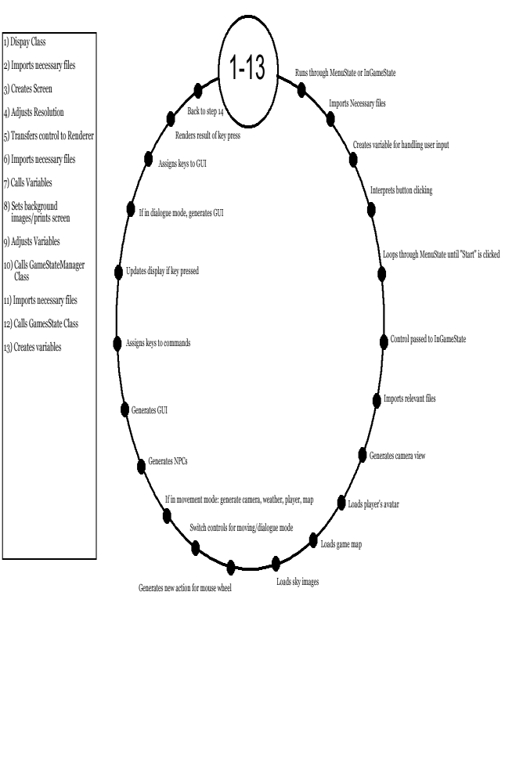
[Game Object Data]

Zoo Escape contains twelve characters. These are Poncho the flamingo, Marvin the giraffe, Rodger the kangaroo, Mei Ling the panda, Abella the tiger, Daisy the meerkat, Jerry the woodpecker, Billy the penguin, Jorge, Miercoles, and Santiago the turtles, and Vladikov the elephant. These characters require certain data structures to ensure that they are believable characters and appear to the player to be more than just lines of code. These requirements are position, facing, direction, model data, movement speed, turn speed, and animation. To make the animation smooth a loop construct must be in place to determine the particular character’s state and then play the appropriate animation. This gives the animal a more natural-looking movement.

Along with the data structures that support the characters, there are also data structures that are required to support the gameplay. The core mechanics of the game include 3 main actions—evading guards, exploring the zoo, and collecting animals/items. In order to create and support these actions and make the game what it is, classes and methods. Classes are groups of methods, which are the pieces of code that create and run the game itself.

The exploring part of the game will involve the data from the InGameState class. Here, using the handleInput method, it will detect the keys being pressed and use that information to move the character through the zoo.

The evade part of the game will also use the class InGameState along with the classes GameLogic and Guard. Detection of movement occurs within the InGameState class. A second important method within that class is the method stealthMode. When the corresponding button is pressed, the animal will move slower and reduce its ability to be detected. The GameLogic class has a method called .process which determines collision of objects. The Guard class contains the visualRadius and audibleRadius methods, which make up the guard’s AI.

The final core mechanic involves collecting objects around the map. This involves the GameLogic class and the .process method to detect the player’s collision with the item or animal they are collecting or rescuing. Once collected, InGameState records the variables that correlate to the items and animals. Then using these variables the game engine can allow you to use the animal or object that you found.
[Data Flow]

There are no save files in Zoo Escape, so the player must complete the game in one sitting. This is not expected to take a large amount of time, however. The only information that is saved is the screen resolution, music volume, action volume, and key bindings. Other than these settings, the information only exists as a single instance.

The data stored throughout the game will be composed of the animals currently saved, the inventory of the player, which quests are being undertaken or have already been completed, and the choices made by the player throughout the game that give the data that is used to analyze the Habits of Mind being presented by the user. The analysis data—which is the only data that is critically important to the game—will be sent in a packet to the server.
[Physics & Statistics] Find out about important variables—probably needs to be done in PM

Points/Lives
Zoo Escape does not have a life or health system, although the character can be caught by the guards. When this occurs, the player is returned to their cage, and all other released animals hide in a bush. This can occur an infinite amount of times without ending the game, it merely sets the player back in progress and they must sneak past guards to get back to the cage they were at.

The inclusion of a point system was also considered irrelevant to the eventual goal of the game. The player’s progress is tracked by the animals they have released, but the important information is the psychological data, and so a conventional “score” is unnecessary.

Collision
When the game detects objects within certain proximity of eachother, they are considered to be in a collision. If they have only just barely come into contact, both objects’ velocity towards eachother ceases. If one object overlaps another, such as a character’s outline passing into the side of a building, the object is bounced back with a force dependant on the amount of overlap. If both overlapping objects are non-static, such as that same character running into a patrolling guard, both objects are pushed backwards.

[Artificial Intelligence]

The game will make some decisions independent from the player. This “AI” will give the game a sense of realism. The predominant place you will find this implemented is in the guards. They patrol and search on their own and make decisions written by the programmers. In programming, to give the guards a command, you must use an “if” statement. This will tell the guard “if”, what you define happens, then execute this code.

For example, if I want the guard to have a sense of sound, I may say that “if” an animal is within a certain radius from the guard, have him turn and walk toward the “sound.” As more animals escape the guards will become more “paranoid”, or have their radius of “hearing” extended. This will increase the difficulty of the game play along with the player’s skill.
[Multiplayer/Networking] Grammar, structure, data

A connection method is a way to connect our gaming computers to the server that processes the packets sent. The connection method our game supports is called TCP or Transmission Control Protocol. This method is considerably slower than the alternative method of UDP (User Datagram Protocol), yet has a much smaller chance to miss the data packets.

As you may be wondering, a packet is a, “unit of data that is routed between an origin and a destination on the Internet or any other packet-switched network.” (searchnetworking.techtarget.com…) The packet sent by our game will be as large as the amount of space required for the psychology data and possibly the score. Our game will send 7 packets at the end of the game unless the packet is “missed” which it will then simply re-send the packet.

The packets will be comprised of the 7 different habits of mind scores the player received. The habits of mind variables are, Initiate, Investigate, Collaborate, Communicate, make Connections, Reflect on Learning, and Imagine/Create. These variables are string formatted, or in a collection of scores.
[User Interface] Add the text component, explain the sub-menus. Where does Options lead and where is the graphic? Also, there is no Login Screen per se, ask Ms. O and she can explain it.

Screens Menus Sub-Menus
Login Screen Start Objectives Menu
Front Page Options Dialogue
Main Screen Quit Mini-Game
Credits Game Menu Freed Animals
Score Bush
Items

User Name

Password

Start
Options
Quit

BushItem PanelParty
Credits
Aaksjdbkshfkdfkfsdkjfhksdhfkdhfksdjhfkjdsfdf

Sdkdkfjhshkshgkjhgkhkjhskfhkfjhk

Ksdhkjhgkdhfgk;hg;kghksdhgk;sdhgk;sghk;
Score
HOM

[Art, Video, Sound] this paragraph hurts my head needs major work

The art is stored in .avi files and loaded by a program named loaded texture. The animation is done by time steps cycling through each frame and then we have top line them up so they create a certain motion or action. The art requirements are 3d world but it is going to have a cartoon look to it. The resolutions to the map and materials are by squares. The sound was copied from one of our programmer’s previous game. Sounds are to be triggered by sound events such as walking and talking and the background music is played as the game starts.
[Level specifics]

What is a level?

In just about every computer or video game that has been created there are defined levels. However, what are levels? Level (as defined by Wikipedia) is a separate area in a game's virtual world. However, not all games have the same types of levels. Some levels are the basic type, as seen in Super Mario World, that all you have to do is get from point A to point B. There are also more complex level systems, like Sonic the Hedgehog and the Secret Rings, where you have to find objects that are hidden within the level and with a limited amount of time.

The start and end of levels

In Zoo Escape we don’t have any defined levels; we have overworlds. Overworlds are a bit like levels but they are just big maps that have sub-maps that you would do tasks inside of (Wikipedia). In our game we have guards that walk around the zoo and make sure that nothing escapes. Every time you release an animal the guards’ eyesight gets more acute and he gets faster. However, there are certain things that you can use to deter the guards, throughout the level there will be party poppers placed that will temporarily distract them so you can escape. However, not only do the guards get smarter the tasks to get the animals out gets harder. In the first one all you have to do is pull a leaver to help the turtles escape, but in the end you have to strategically knock a boulder off a fountain to hit the gate in just the right spot in order to escape.

The use of levels

The use of levels in games is very important. Not only does it make the games more fun to play it allows the game to increase in difficulty easily. In having levels in a game it makes hardware limitations less. The hardware has a lot of things to draw during a game, as in all the different types of moves that a player can make throughout the game. The hardware of a game also has to draw the foes and such as the game goes along, if you don’t have levels, however, if there are levels in the game the hardware only has to draw them once.
[Appendix A] Make sure list is complete

3ds Max A program used to create 3d objects
AI Artificial intelligence
AMD Athlon A type of processor chip
Avatar An image that portrays a person
.avi Video file format with sound
Class A compilation of like-intent methods of code
Core Mechanics The basic gameplay you do over and over again
Eclipse Handles the daily builds
Freeware Programs created for public use, downloaded free from the internet
GameLogic Process which determines collision of objects
GUI (Graphical User Interface) The visible, interactive area of the screen
IDE (Integrated Development Environment) Software that assists programmers
Java A common programming language
JCreator A program for coding in java
Method A group of code with a specific purpose
NPC (Non-Playing Character) A character not controlled by the player
Object An instance of something in a game (i.e. a character, the ground, a pen…)
OpenAL Opens and draws the audio Max files
OpenGL Opens and draws the graphical Max files
Packet A unit of data that is routed between an origin and a destination on the Internet or any other packet-switched network
RAM (Random Access Memory) Memory used to store programs
SDK (System Development Kit) Used to create applications
TCP (Transmission Control Protocol) Used to create connections to exchange data streams
UDP (User Datagram Protocol) Programs on computers that can send short messages
Variables An instance in coding that stores data, much like variables in algebra

[Appendix B]

Packages
Make sure that your package names are unique by prefixing them with the inverted name of your internet domain.

Classes
A class name should begin with a capital letter and be written in mixed case. If a class name consists of more than one word, each word should begin with a capital letter. Since classes are designed to represent objects, class names should be named after nouns.

Interfaces
Interface names follow the same capitalization conventions as class names. When an interface is used to provide additional information about the classes that implement it, it is common to choose an interface name that is an adjective. When an interface works more like an abstract superclass, use a name that is a noun.

Methods
Method names always begin with a lowercase letter. If the name contains more than one word, every word after the first is to begin with a capital letter. Method names are typically chosen so that the first word is a verb. Method names can be as long as is necessary to make their purpose clear, but choose succinct names where possible.

Fields and constants
Non-constant field names are the same capitalization conventions as method names are. If a field is a static final constant, it should be written in uppercase. If the name of a constant includes more than one word, the words should be separated by underscores. A field name should be chosen to best describe the purpose of the field or the value it holds.

Parameters
The names of method parameters appear in the documentation for a method, so you should choose names that make the purpose of the parameters as clear as possible. Try to keep parameter names to a single word and use them consistently.

Local variables
Local variable names are an implementation detail and never visible outside your class. Nevertheless, choosing good names makes your code easier to read, understand, and maintain. Variables are typically named following the same conventions as methods and fields.
In addition to the conventions for specific types of names, there are conventions regarding the characters you should use in your names. Also, Java allows names to use any alphanumeric characters from the entire Unicode character set. The use of Unicode characters should typically be restricted to local variables, private methods and fields, and other names that are not part of the public API of a class.
[Appendix C] Check data, ensure it matches format

- Firstly, a new folder, preferably upon the desktop, must eb created, then through the use of Tortoise SVN, the repository of all of our files are available at https://ridiculous.googlecode.com/svn/trunk, which, when downloaded through Tortoise, along with your username and password, will download the entire repository to whatever folder you have indicated. To download these files, you must have the Tortoise SVN client, and then you must right-click the folder, hit SVN Checkout, and then input the web address provided.
- Our complier is Jcreator 4.00LE, which handles the coding alongside Eclipse, which handles the daily builds.
- IDE (Integrated Development Environment) = Eclipse as the world builder.
- SDK (System Development Kit) = Java 1.6

[Appendix D] Needs screenshots

[Network Communication Diagram]

Client

Client

Client

Server
Website
&

Score

